**Facial Expression Classification Using Deep Convolutional Neural Network**

Deep Learning Model to identify emotion of people based on facial expression

Group Members:

11815050: Santosh Mahato

11805178: Alok Kumar Tiwari

11804312: Shivam Yadav

Lovely Professional University

School of Computer Science and Engineering

Advance Machine Learning

**Abstract**

In this project, we made a facial expression recognition using CNN (Convolutional Neural Network), one of the deep learning technologies. The proposed structure has general classification performance for any environment or subject. For this purpose, we collect a variety of databases and organize the database into six expression classes such as ‘expressionless’, ‘happy’, ‘sad’, ‘angry’, ‘surprised’ and ‘disgusted’.

Pre-processing and data augmentation techniques are applied to improve training efficiency and classification performance. In the existing CNN structure, the optimal structure that best expresses the features of six facial expressions is found by adjusting the number of feature maps of the convolutional layer and the number of nodes of fully-connected layer.

The experimental results show good classification performance compared to the state-of-the-arts in experiments of the cross validation and the cross database.

**Table of Content**

* Introduction
* Dataset Used
* Proposed Architecture
* Results and Experimental analysis
* All output Screenshots
* Conclusion and Future Scope
* References

**INTRODUCTION**

Emotion is triggered by specific situations, and the recognition of human emotion is a crucial topic in the study of human-computer interfaces (HCIs) to empathize with people. When a machine communicates with people, emotion detection can give people more affinities and help to provide personalized service to people depending on their moods, which inspires confidence in people.

Face recognition is the task of identifying an already detected object as a known or unknown face. Often the problem of face recognition is confused with the problem of face detection Face Recognition on the other hand is to decide if the "face" is someone known, or unknown, using for this purpose a database of faces in order to validate this input face. In order to recognize facial expressions based on CNN, a much amount of well-separated training database is needed.

Deep learning can overcome the technical limitations of existing machine learning where the performance is drastically deteriorated for complex problems by using deep neural networks to extract high-level features appropriate to the given data. Convolutional Neural Networks (CNN) are developed to imitate human visual cognition processes in deep learning technology and has been widely applied to the field of image recognition and shows high performance.

The basic CNN structure consists of convolutional layers and fully-connected layers. By passing through multiple convolutional layers sequentially, it is found to extract high-level features. With the extracted high-level features, the final classification result is determined in the Fully- connected layer. The 7 expressions to be classified are ‘neutral’, ‘happy’, ‘sad’, ‘angry’, ‘fear’, ‘surprised’ and 'disgusted'.

**Dataset Used**

First, a database containing a large number of facial images is required for recognition of facial expressions with high accuracy. The images of the database should consist of facial images representing emotions. The database used in the ‘Facial Expression Recognition Challenge’ held in Kaggle in 2013(FER2013) consists of 37,000 facial images of seven facial expressions.

|  |  |  |  |  |  |  |  |
| --- | --- | --- | --- | --- | --- | --- | --- |
| Dataset | Fear | Surprise | Angry | Sad | Happy | Disgust | neutral |
| Train | 4097 | 3171 | 3995 | 4830 | 7215 | 436 | 4965 |
| Test | 1024 | 831 | 958 | 1247 | 1774 | 111 | 1233 |

Fig: Dataset distribution among various emotions

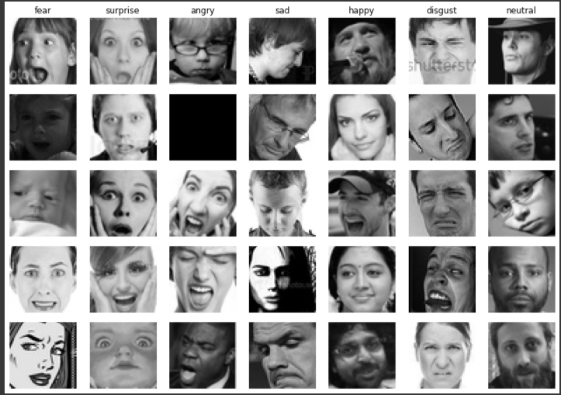

Fig: Images taken from Kaggle FER (2013) Dataset

**Proposed Architecture**

We have use convolutional neural network to train our model for facial emotion recognition as it is most commonly applied to analyze visual imagery.

And also, we have used ‘adam’ optimizer with learning rate of 0.01% to compile this model. We have also used ‘categorical_crossentropy’ function as loss function.

CNN (Convolutional Neural Network)

The CNN framework is widely used for learning features and classification in various fields. It consists of a feature extraction part and a classification part. The feature extraction section is composed of successive convolution layers and pooling layers with nonlinear functions.

The first convolutional layer filters (48×48) size input image with 32 kernels of size 3×3 with ‘same’ padding and ‘relu’ activation function. The second convolutional layer takes as input the output of the first convolutional layer and filters it with 64 kernels of size 3× 3 with ‘same’ padding and ‘relu’ activation function. Then we have added Batch-Normalization to the model to normalize the inputs. Then we have added MaxPooling2D with ‘pool_size’ (2,2) to reduce the number of parameters and computation in the network. Then we have added Dropout with rate 25% to prevent a model from overfitting by randomly setting the outgoing edges of hidden units.

The third and fourth convolutional layers as well as first and second convolutional layers are connected to one another without any intervening pooling or normalizing layers. The third convolutional layer has 128 kernels of size 3×3 connected to the outputs of the second convolutional layer. The fourth convolutional layer has 256 kernels of size 3×3. Then Again, we are adding ‘Batch-Normalization’ to the model. Then again, we are adding MaxPooling2D with pool_size of (2,2) and also adding Dropout with rate 25%.

Then Finally, we are adding flatten to our model to convert the data into a 1-dimensional array. Then we are adding Dense layer with dimensionality of output variable as 1024 with activation function ‘relu’ to feed all outputs from the previous layer to all its neurons. Then Again, we are adding Dropout with rate 50%. Then Finally, we are adding Dense layer with output variable as number of emotions i.e., 7 with activation function as ‘softmax’.

To prevent over-fitting, the dropout technique is applied to the first two fully-connected layers. In the facial expression recognition, the number of channels in the convolutional layer and the number of nodes in the fully-connected layer is reduced in order to select an optimal structure with superior classification performance, less execution time and less training parameters.

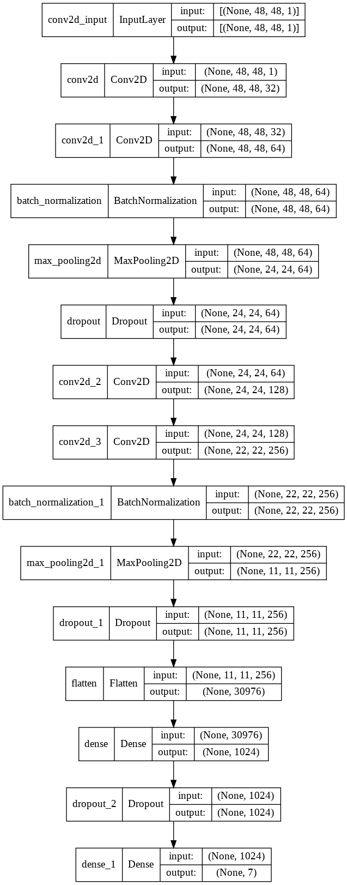

Fig: My CNN Model

**Results and Experimental analysis**

Testing Result final:

Batch tested: 113/113

Average train time: 4s

Execution time: 31ms/step

loss: 1.1205

accuracy: 0.6640

Training Result final:

Batch trained: 449/449

Average train time: 26s

Execution time: 57ms/step

loss: 0.4634

accuracy: 0.8775

Final train accuracy = 87.75%,

validation accuracy = 66.40%

**Classification Report:**

For Training Dataset:

|  |  |  |  |  |
| --- | --- | --- | --- | --- |
|  | Precision | Recall | F1-Score | Support |
| Angry | 0.14 | 0.14 | 0.14 | 3995 |
| Disgust | 0.02 | 0.01 | 0.01 | 436 |
| Fear | 0.14 | 0.13 | 0.13 | 4097 |
| Happy | 0.25 | 0.25 | 0.25 | 7215 |
| Neutral | 0.18 | 0.19 | 0.18 | 4965 |
| Sad | 0.17 | 0.17 | 0.17 | 4830 |
| Surprise | 0.11 | 0.11 | 0.11 | 3171 |
|  | | | | |
| Accuracy |  |  | 0.17 | 28709 |
| Macro avg | 0.14 | 0.14 | 0.14 | 28709 |
| Weighted avg | 0.17 | 0.17 | 0.17 | 28709 |

For Testing Dataset:

|  |  |  |  |  |
| --- | --- | --- | --- | --- |
|  | Precision | Recall | F1-Score | Support |
| Angry | 0.13 | 0.13 | 0.13 | 958 |
| Disgust | 0.03 | 0.02 | 0.02 | 111 |
| Fear | 0.14 | 0.11 | 0.13 | 1024 |
| Happy | 0.25 | 0.25 | 0.25 | 1774 |
| Neutral | 0.17 | 0.20 | 0.19 | 1233 |
| Sad | 0.19 | 0.18 | 0.19 | 1247 |
| Surprise | 0.10 | 0.10 | 0.10 | 831 |
|  | | | | |
| Accuracy |  |  | 0.17 | 7178 |
| Macro avg | 0.14 | 0.14 | 0.14 | 7178 |
| Weighted avg | 0.17 | 0.17 | 0.17 | 7178 |

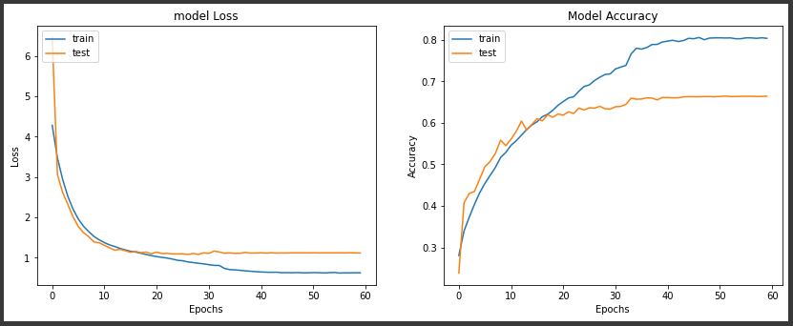

Fig: Accuracy graph for training and testing dataset

**All output Screenshots**

**Color Bar Representation:**

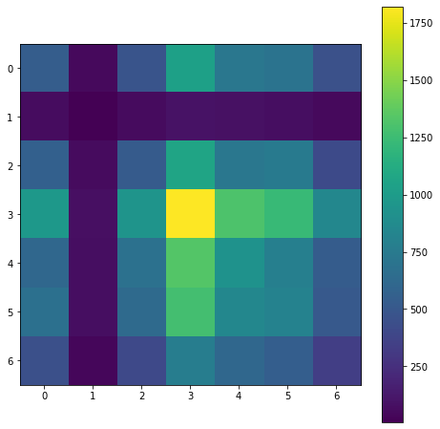

Fig: Color-bar representing Training Dataset

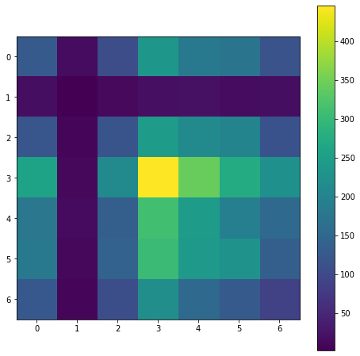

Fig: Color-bar representing Testing Dataset

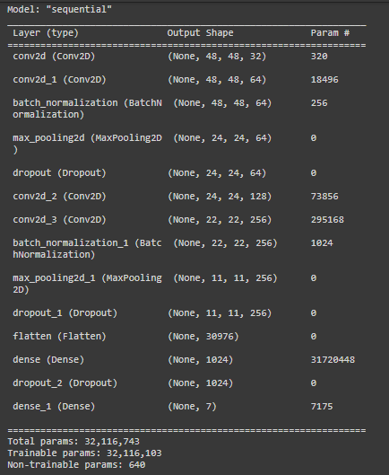

Fig: Layer-wise Model

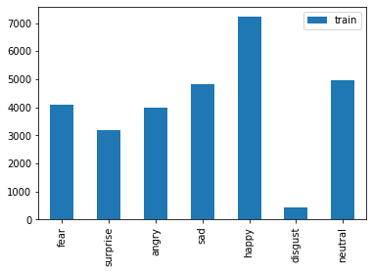

Fig: Bar-diagram of emotion classes vs Images quantity in Training dataset

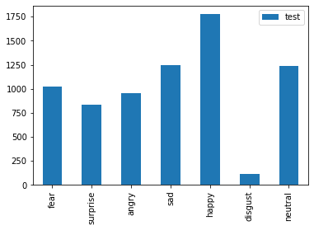

Fig: Bar-diagram of emotion classes vs Images quantity in Testing Dataset

**Conclusion**

In this paper, we propose a deep CNN for automated facial expression recognition algorithm for seven expressions of ‘neutral’, ‘happy’, ‘sad’, ‘angry’, ‘fear’, ‘surprised’ and ‘disgusted’. The structure of the proposed algorithm has good generality and classification performance.

In the existing CNN structure, the optimal structure for reducing the execution time and improving the classification performance was determined by adjusting the number of feature maps in the convolutional layer and the number of nodes in the fully-connected layer. Experimental results confirmed the effectiveness of data preprocessing and augmentation techniques.

**Future Scope**

As we know the facial expression recognition system are deploying in different civilian industry and defense industries are try to deploy in their security system so that they can enhance the performance of and security of their equipment. And the demand of these kind of system will going to increase in future*.*

**References**

[1] <https://www.youtube.com/watch?v=avv9GQ3b6Qg>

[2] <https://analyticsindiamag.com/10-face-datasets-to-start-facial-recognition-projects/>

[3] <https://www.kaggle.com/msambare/fer2013/activity>